Annual Business Meeting
May 18, 2015
Little Rock, Arkansas
Minutes

Call to Order: Alison Davis called the meeting to order at 1:07 pm Central.
President Alison Davis opened the meeting by reviewing a few of NACDEP’s accomplishments over the last year and reasons why NACDEP is important to our profession.
Approval of the Consent Agenda: Michael Dougherty moved to approve the agenda. Susan Kelly seconded the motion. Motion passed.
Past President Alison Davis handed over the gavel to President Stacey McCullough. President McCullough recognized members of the New NACDEP Board. The 2015-2016 NACDEP is comprised of:
President: Stacey McCullough
President-Elect: Josh Clements
Past President: Alison Davis
Treasurer: Notie Lansford
Secretary: Julie Fox
South Rep: Susan Kelly
Northeast: Kelly Nix
North Central: Connie Mefford
West: Roslynn Brain
1890: Adam Hodges
1994: John Phillips

2014-2015 Committee Chairs were recognized. 2015-2016 Committee Chairs were introduced. They are:

Resolutions & Policy: Alison Davis
Finance: Nancy Bowen-Elzey
Nominations: Alison Davis
Communications: Brian Raison
2016 Conference: Joshua Clements
Member Services:
Recognition: Michael Dougherty
Marketing: Rebekka Dudensing
Development: Michael Wilcox & Melissa Bond

Outgoing Board Members were recognized for their service to NACDEP. Outgoing members included:

Mark Apel (Western Rep.); Michael Darger (Past President); Kenyetta Nelson-Smith (1890 Rep.); and Michael Wilcox (Secretary)
NACDEP’s new Association Management firm, The Association Source (TAS), was introduced. Our TAS liaison and NACDEP Executive Director, Ricky Atkins was present.

Treasurer’s Report

The NACDEP Annual Financial Report (2014) was delivered by Treasurer Notie Lansford.

NACDEP’s End-of-year Income Statement (from December 31, 2014) was discussed:
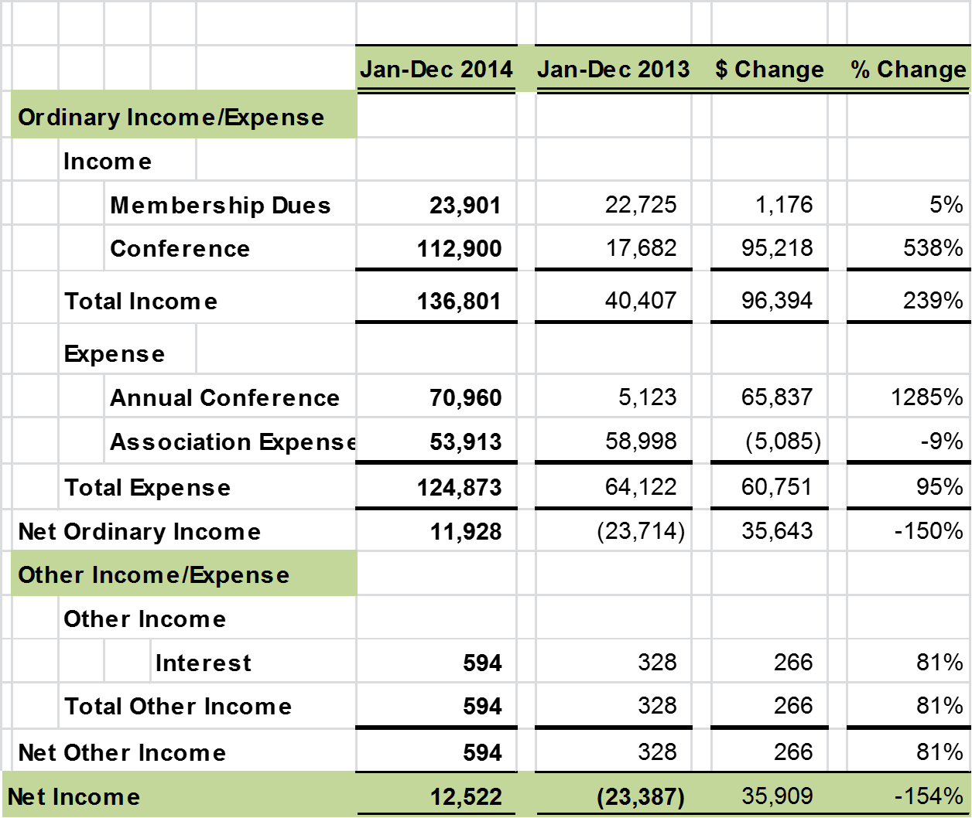

In 2013 the Galaxy combined Extension conference impacted NACDEP financials.

NACDEP’s End-of-year Balance Sheet (from December 31, 2014) was discussed:
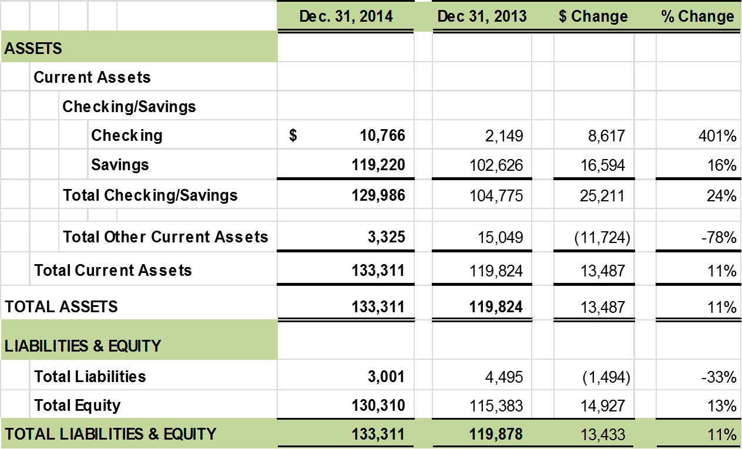

Committee Reports

Finance Committee Nancy Bowen-Elzey
Bowen-Elzey introduced the members of the Finance Committee and explained the function of the committee. She reported on the annual spot audit, which is conducted after the conference each year, noting that the conference generates 70% of NACDEP revenue. A full and formal audit was conducted last year and will continue to be conducted every three years. Their only finding concerned NACDEP use of the Association’s credit card.

Communications Committee Brian Raison
Raison went over the Committee’s roles and current projects (newsletter, website, social media, etc.).
Raison reported on the committee progress as they have worked with the new management company to launch the new website, online database, and social media. He encouraged people to update their online profiles.

Member Services Committee Mary Martin
Martin discussed the role of the committee. She announced the nine scholarship recipients. All recipients are presenting at the 2015 meeting.

2015 Conference Scholarship Recipients
  - Roslynn Brain
  - Travis Cullen
  - Daniel Fagerlie
  - Greg Felson
  - Sheila Gray
  - Susan Kerr
  - Debra Jo Kinsella
  - Amanda Philyaw Perez
  - Gary Selby

State/Regional Chapters Committee Trudy Rice
As a Special Issues committee, Rice introduced their roles and responsibilities. The committee met with the Board and offered a report that contained suggested changes to the Policies and Procedures and By-laws to clarify language and responsibilities related to local chapters and regional representatives.

Recognition Committee Michael Dougherty
- The plaques and certificates were done and shipped here by TAS.
- The programs were printed and self-delivered.
- The PowerPoints are complete and ready for posting during the dinner.
- The script has been updated, finalized, and delivered to the MC.
- The arrangements for photos of winners have been made.
- The regional representatives have been consulted regarding the presentations of awards at that level.

Presentation of Joint Council of Extension Professionals (JCEP) Professional of the Year Award by Dean Solomon, Peggy Ehlers, Judith Barth to Ryan Pesch.

Development Committee Michael Wilcox
Wilcox introduced the new committee established to improve the financial sustainability of NACDEP. Initial plans are to generate contributions to develop an endowment. As a new committee, they are seeking additional members.

Marketing Committee Michael Darger
Michael Darger, filling in for chair Rebekka Dudensing, described the work of the Marketing Committee and outlined the following:

Mission

NACDEP is an organization dedicated to improving the visibility, coordination, professional status and resource base of community and economic development Extension programs and professionals.

Vision

Advocating community and economic development programming, while educating and recognizing Extension professionals who develop successful programs and expand resources to strengthen communities.

Values
- Economic and Business Development
- Leadership Development and Civic Engagement
- Local Government/Nonprofits and Public Decision Making
- Land Use Planning and Housing
- Tourism, Arts, and Creative Placemaking
- Core Skills: Facilitation, Inclusion, Collaboration, Analysis, Evaluation, and Planning
- Integrative work on emerging issues across Extension:
  - Environment and climate change
  - Local food systems
  - Public health and poverty
What is Community Development? (Please see: http://www.nacdep.net/what-is-community-development- )

Resolution & Policy Committee Michael Darger
Michael Darger outlined the three proposed amendments to the By-laws.

Michael Dougherty moved to divide the question (Proposed Bylaw changes I and II and Proposal III). Alan Barefield seconded. The Motion passed by the required 2/3 majority. Michael Dougherty moved to consider the first question. The motion passed and the Proposed Amendment I and II were approved.

By-laws proposed changes
Proposed Amendment 1. Article VII – Voting
Section 3. Procedure for Simple Majority Votes.
Except for amendments to the Bylaws (Article XIV) or policy statements
(Article VIII), the Executive Committee may submit any question by mail or email to the eligible membership for a simple majority vote. Such questions shall be returned within thirty days of the submission of the question to the entire membership. (Amended
Proposed Amendment 2. Article VIII: Policy Statements
Section 1. Definition.
Policy statements are those motions or resolutions passed by the Executive Committee that express the attitude and wishes of the Association. They shall supplement the Bylaws and shall serve as directives to the officers expressing the official stand or opinion of the Association. Policy statements shall in no way bind an individual when expressing the opinion of the Association (Amended February 2006, April 2007, April 2009, and May 2015).
Proposed Amendment 3. Article XIV: Amendments
The Bylaws of the Association may be amended by the vote of a minimum of one-fifth two-thirds majority vote of the eligible members voting at the annual meeting. A two-thirds majority of those voting is required for passage of an amendment. Amendments may be proposed by any eligible member. Changes to the Bylaws shall be coordinated by the Resolutions and Policy Committee. The Committee shall review amendments for consistency and coordination with the existing Bylaws but may not veto any proposed amendment.
After review, the Resolutions and Policy Committee shall submit proposed amendments and the rationale to all eligible members by mail, or email or fax at least thirty sixty days in advance of the close of balloting.
A comment period of thirty days will be held and immediately followed by a thirty day balloting period. This comment and voting process will be held annually preceding the annual meeting. The comment process will occur via website or other electronic methods deemed appropriate by the Resolutions and Policy Committee. The ballot shall include a copy of the proposed amendment, the rationale for the amendment, and the portion of the Bylaws that are affected. (Amended February 2006, and April 2007 and May 2015).
Discussion: Steve Burr asked the Board to clarify the motion and discuss the motivation for the amendment. Michael Darger and Notie Lansford discussed some of the limitations associated with current suggested amendments. Some members voiced concerns regarding the ‘lowering of the bar’. The overarching rationale is a movement towards being able change the By-laws throughout the year rather than waiting for the annual meeting. It was mentioned that there were a ‘flurry’ of changes to the Bylaws in the early years of NACDEP. As we mature as an organization, there will be continued changes.
Motion to approve the second question failed in a rising (standing) vote.
New Leadership Opportunities in NACDEP were announced. These include:
- Member Services Committee Chair
- PILD Committee Representative
- Nominations committee will be looking for 2016-2017 NACDEP leaders
President Stacey McCullough made a few announcements regarding regional meetings.
President-elect Joshua Clements discussed the 2016 Joint Conference with ANREP in Burlington, VT.
President Stacey McCullough discussed the potential Joint Conference with the Community Development Society in 2017.
Stacey ended the Business Meeting by discussing why NACDEP is important and suggested that NACDEP will continue moving forward and evolving.
Brian Raison moved to adjourn the meeting. Motion passed.
Meeting was adjourned.

